**TUTORIAL 6**

1. Write a database descrip tion for each of the relations shown, using SQL DDL (shorten, abbreviate, or chan ge any data names, as needed for your SQL version). Assume the following attribut e data types:

StudentID (integer, primary key), StudentName (25 characters), Fac ultyID (integer, primary key), FacultyName (25 characters), CourseID (8 characters, primary key), CourseName (15 characters), DateQualified (date), SectionNo (integer, primary key), Semester (7 characters)

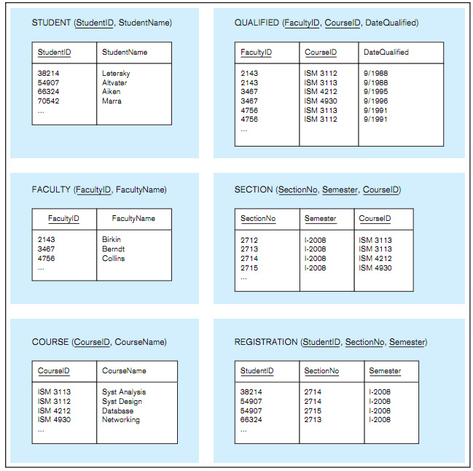

**2**. Create an SQL VIEW for foollowing table

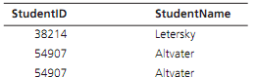

**3**. Write SQL data definition c ommands for each of the following queries:

a. How would you add an attribute, Class, to the Student table?

b. How would you remove the Registration table?

c. How would you change the FacultyName field from 25 characters to 40 characters?

1. Write SQL commands for the following:

a. Create two different forms of the INSERT command to add a student with a student ID of 65798 and last name Lopez to the Student table.

b. Now write a command that will remove Lopez from the Student table.

c. Create an SQL command that will modify the name of course ISM 4212 from Database to Introduction to Relational Databases.

**5**. Write SQL queries to answer the following questions:

a. Which students have an ID number that is less than 50000?

b. What is the name of the faculty member whose ID is 4756?

c. What is the smallest section number used in the first semester of 2008?

**6**. Write SQL queries to answer the following questions:

a. How many students are enrolled in Section 2714 in the first semester of 2008?

b. Which faculty members have qualified to teach a course since 1993? List the faculty ID, course, and date of qualification.

**7**. Write SQL queries to answer the following questions:

a. Which students are enrolled in Database and Networking? (Hint: Use SectionNo for each class so you can determine the answer from the Registration table by itself.)

b. Which instructors cannot teach both Syst Analysis and Syst Design?

**8**. Write SQL queries to answer the following questions:

a. What are the courses included in the Section table? List each course only once.

b. List all students in alphabetical order by StudentName.

c. List the students who are enrolled in each course in Semester I, 2008. Group the students by the sections in which they are enrolled.

d. List the courses available. Group them by course prefix. (ISM is the only prefix shown, but there are many others throughout the university.)

**SOLUTION**

**1.**

CREATE TABLE STUDENT (

STUDENT_ID INTEGER UNSIGNED NOT NULL,

STUDENT_NAME VARCHAR(25),

CONSTRAINT STUDENT_PK PRIMARY KEY (STUDENT_ID)

);

CREATE TABLE FACULTY

(

FACULTY_ID INTEGER UNSIGNED NOT NULL,

FACULTY_NAME VARCHAR(25),

CONSTRAINT FACULTY_PK PRIMARY KEY (FACULTY_ID)

);

CREATE TABLE COURSE

(COURSE_ID CHAR(8) NOT NULL,

COURSE_NAME VARCHAR(15),

CONSTRAINT COURSE_PK PRIMARY KEY (COURSE_ID));

CREATE TABLE SECTION

(

SECTION_NO

INTEGER

UNSIGNED NOT NULL,

SEMESTER

CHAR(7)

NOT NULL,

COURSE_ID

CHAR(8),

CONSTRAINT SECTION_PK PRIMARY KEY (SECTION_NO, SEMESTER),

CONSTRAINT SECTION_FK FOREIGN KEY (COURSE_ID) REFERENCES COURSE (COURSE_ID)

);

CREATE TABLE QUALIFIED

(FACULTY_ID

INTEGER

UNSIGNED NOT NULL ,

COURSE_ID

CHAR(8)

NOT NULL,

DATE_QUALIFIED DATE,

CONSTRAINT QUALIFIED_PK PRIMARY KEY (FACULTY_ID, COURSE_

CONSTRAINT QUALIFIED_FACULTY_FK FOREIGN KEY (FACULTY_ID) REFERENCES FACULTY (FACULTY_ID),

CONSTRAINT QUALIFIED_COURSE_FK FOREIGN KEY (COURSE_ID) REFERENCES COURSE (COURSE_ID));

| CREATE TABLE REGISTRATION |  |  |
| --- | --- | --- |
| (STUDENT_ID | INTEGER | UNSIGNED NOT NULL, |
| SECTION_NO | INTEGER | UNSIGNED NOT NULL, |
| SEMESTER | CHAR(7) | NOT NULL, |

CONSTRAINT REGISTERED_PK PRIMARY KEY (STUDENT_ID, SECTION_NO, SEMESTER),

CONSTRAINT STUDENT_REGISTERED_FK FOREIGN KEY(STUDENT_ID) REFERENCES STUDENT(STUDENT_ID),

CONSTRAINT COURSE_REGISTERED_FK FOREIGN KEY (SECTION_NO, SEMESTER) REFERENCES SECTION(SECTION_NO, SEMESTER));

1. CREATE VIEW STUDENT_VIEW AS SELECT STUDENT_ID, STUDENT_NAME FROM STUDENT;

3.

a. ALTER TABLE STUDENT ADD CLASS VARCHAR(5)

b. DROP TABLE REGISTRATION;

1. ALTER TABLE FACULTY MODIFY FACULTY_NAME VARCHAR(50);

4.

a. INSERT INTO STUDENT VALUES (12345, “LOPEZ”);

INSERT INTO STUDENT (STUDENT_ID, STUDENT_LNAME) VALUES (12345, “Kloser”);

b. DELETE FROM STUDENT WHERE STUDENT_NAME = ‘LOPEZ’;

1. UPDATE COURSE SET COURSE_NAME = ‘INTRODUCTION TO RELATIONAL DATABASE’ WHERE COURSE_ID= ‘ISM 4212’;

5.

1. SELECT STUDENT_ID, STUDENT_NAME FROM STUDENT WHERE STUDENT_ID <50000;
2. SELECT STUDENT_NAME FROM STUDENT WHERE STUDENT_ID = 4756;
3. SELECT MIN(SECTION_NO) FROM REGISTRATION WHERE SEMESTER= ‘I-2008’;

6.

1. SELECT COUNT(STUDENT_ID) FROM REGISTRATION WHERE SECTION_NO =2714 AND SEMESTER= ‘I-2008’
   1. SELECT Q.FACULTY_ID, C.COURSE_NAME, Q.DATE_QUALIFIED

FROM FACULTY AS F, COURSE AS C, QUALIFIED AS Q

WHERE YEAR(Q.DATE_QUALIFIED) >= 1993

AND C.COURSE_ID =Q.COURSE_ID;

SELECT FACULTY_ID, COURSE_ID, DATE_QUALIFIED

FROM QUALIFIED

WHERE DATE_QUALIFIED >= ‘1993-01-01';

7. a,

SELECT STUDENT_ID, COUNT(*)

FROM REGISTRATION

WHERE SECTION_NO IN (2714,2715)

GROUP BY STUDENT_ID

HAVING COUNT(*) > 1;

1. SELECT FACULTY_ID,COUNT(*)FROM QUALIFIED WHERE COURSE_ID IN ('ISM 3113','ISM 3112')

GROUP BY INSTRUCTOR_ID HAVING COUNT(*) = 1;

8

1. SELECT DISTINCT COURSE_ID FROM SECTION;
2. B. SELECT STUDENT_NAME

FROM STUDENT

ORDER BY STUDENT_NAME;

1. SELECT SECTION_NO,SEMESTER,STUDENT_ID FROM REGISTRATION

WHERE SEMESTER = 'I-2008'

ORDER BY SECTION_NO, SEMESTER, STUDENT_ID;

1. SELECT COURSE_ID,COURSE_NAME

FROM COURSE

ORDER BY COURSE_ID;